TEST CASES FOR LOGIN USER STORY – ITERATION 2

Test cases for login module – user story number 1, iteration 2.

1. The password entered by the user should be at least 6 characters in length.
2. If user enters wrong sign in credentials, then an error message should be displayed.
3. If user enters correct sign in credentials, then he/she should be directed to a dashboard page.

Case 1: The user enters a password which is less than 6 characters in length as shown in the following figure.

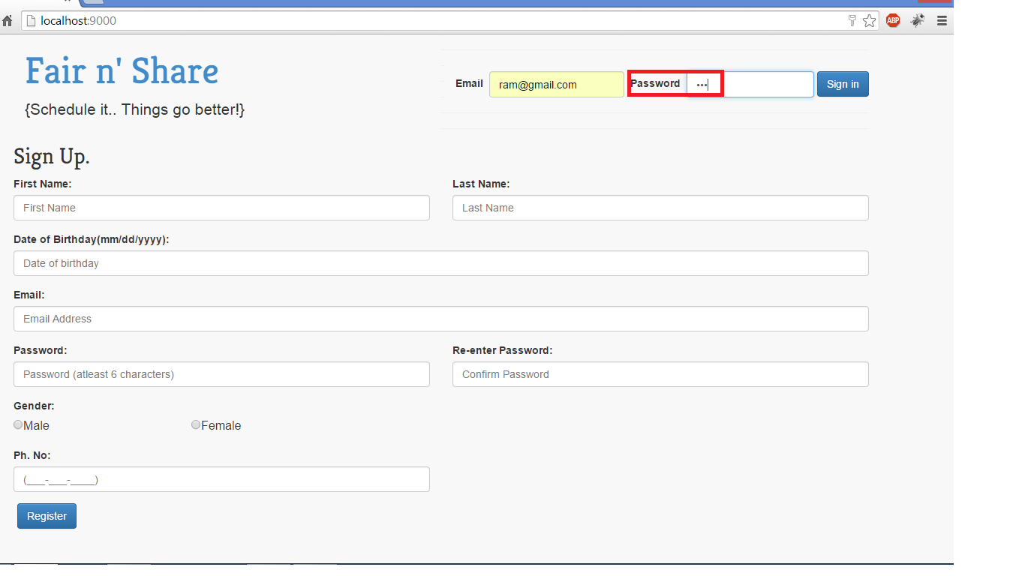

On clicking the Sign in button, the validation is performed and an alert message prompting the user to “enter a valid password” is displayed on the screen (highlighted in red) as shown below:

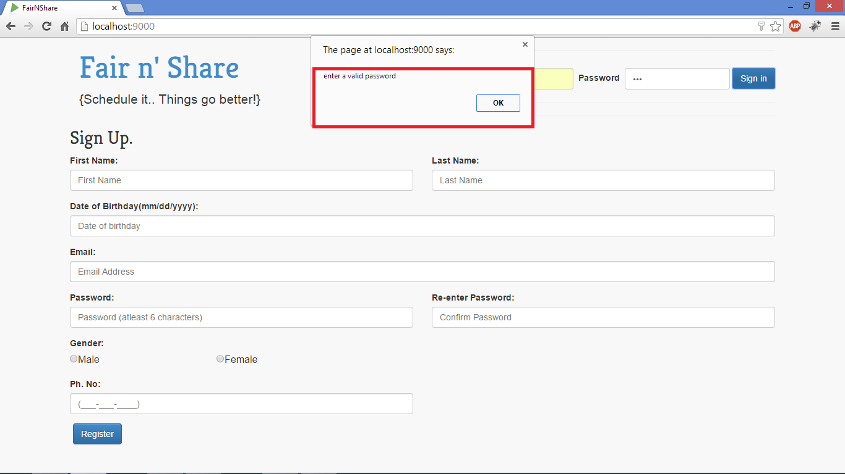

Case 2: If user enters wrong sign in credentials, then an error message should be displayed. If the user enters a wrong password (which is at least 6 characters in length), as shown in the figure below:

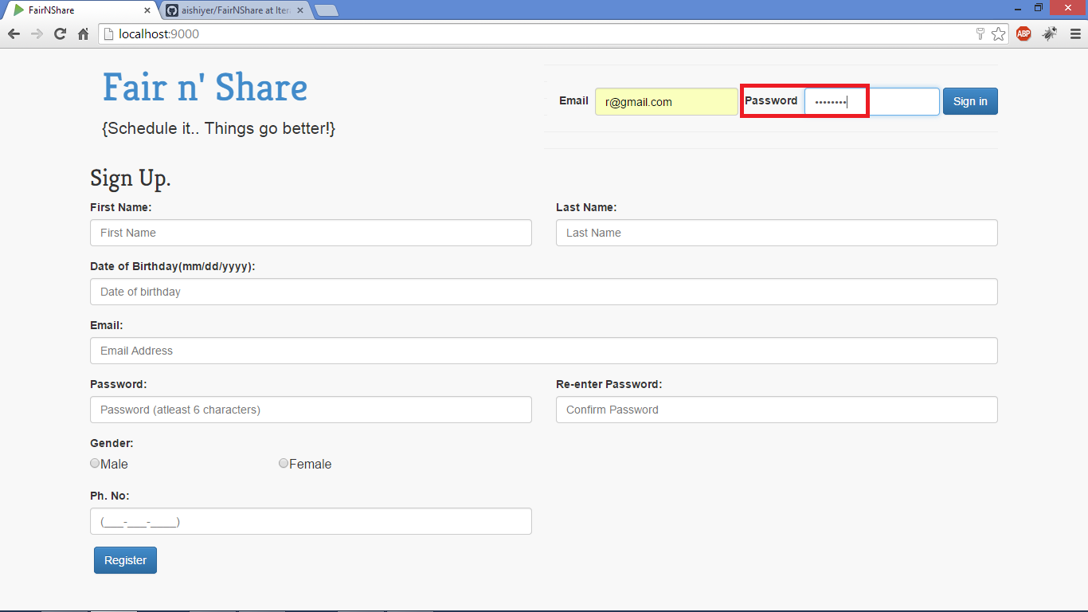

An error message as shown in the figure below will be displayed on the screen.

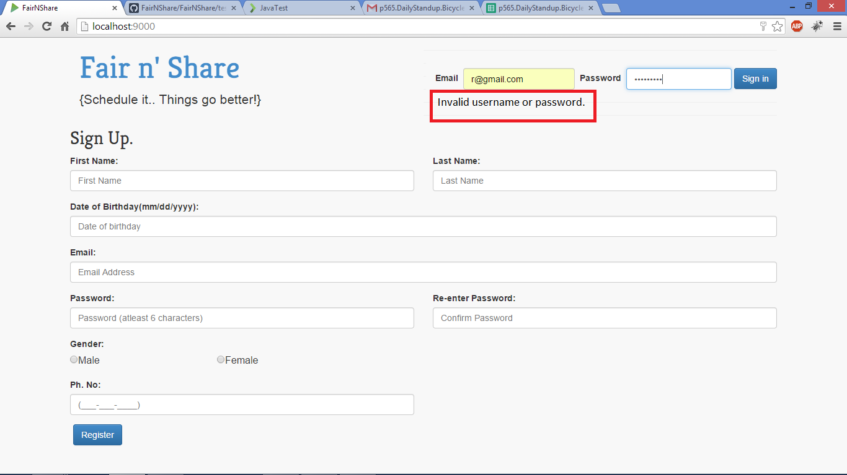

Case 3: If user enters correct sign in credentials, then he/she should be directed to the dashboard page, as shown in the figure below:

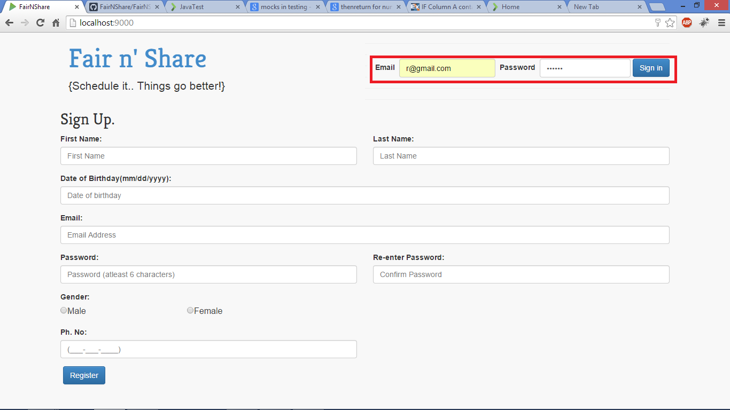

Dashboard page is displayed on successful login!!

